**http://demoinja.com/injuryattorneydirect /**

**Work Documentation flow about InjuryAttornyDirect**

This website fully dependable on POST, POST_TYPE. I have created some posttype. These are mention bellow.

1. Attorney Profile
2. Practice Area
3. Front End Middle Content
4. Workers Compensation
5. Workers Compensation Child

And Some important post which is used in the particular post type. These are.

1. [**attorney profiles top content**](http://demoinja.com/injuryattorneydirect/wp-admin/post.php?post=2903&action=edit)
2. [**workers compensation middle bottom data**](http://demoinja.com/injuryattorneydirect/wp-admin/post.php?post=2901&action=edit)
3. [**workers compensation top data**](http://demoinja.com/injuryattorneydirect/wp-admin/post.php?post=2898&action=edit)
4. **--------------------------Home Page----------------------:**

**a) Header Bar**

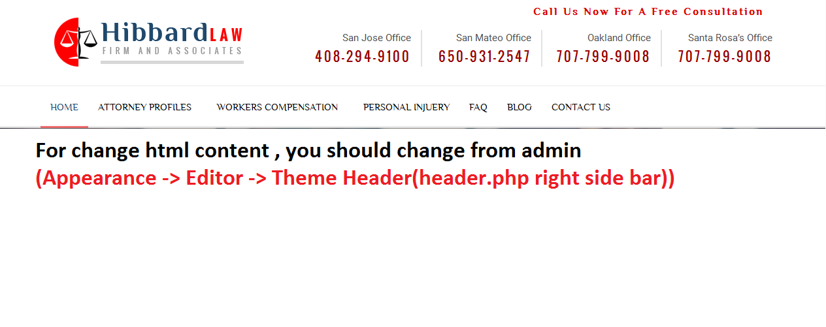

**b)SLIDER:**

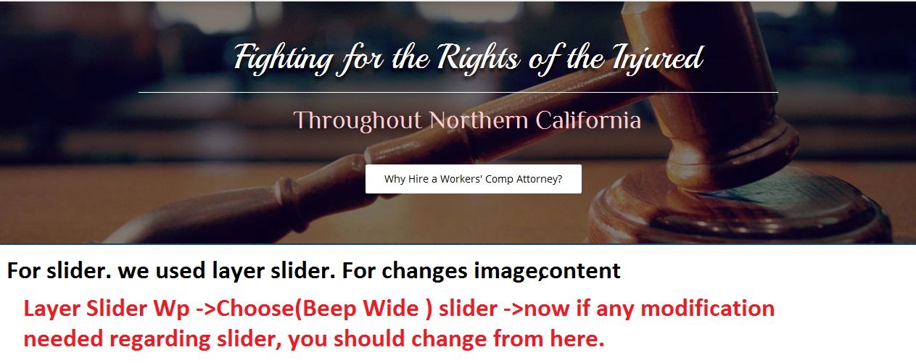

**c)**



**This two section simply html design, from admin .**

**We con modify from admin-> pages-> home page**

**d)**



**For this block, we have a post type.**

**And the Post type name is = Front End Middle Content**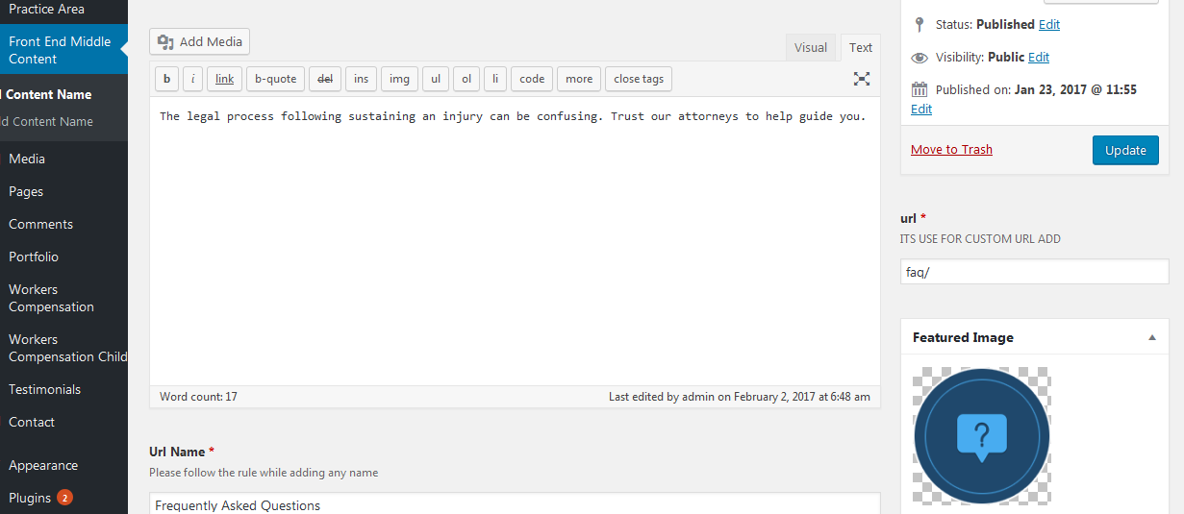

**This url taxonomy used for a button url**

**e)Practice Area Block**

**For this block, I have created one post type. Like the above block. And post type name is-> Practice Area**

**You can see it in left side bar in admin.**

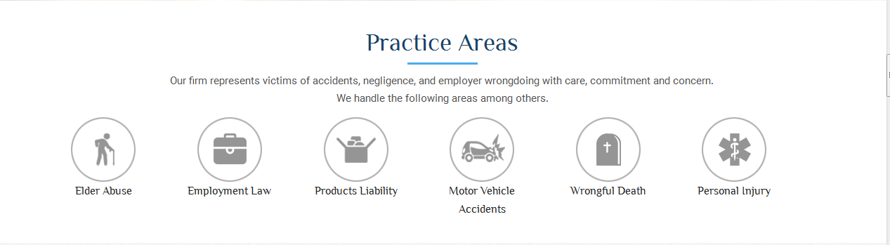

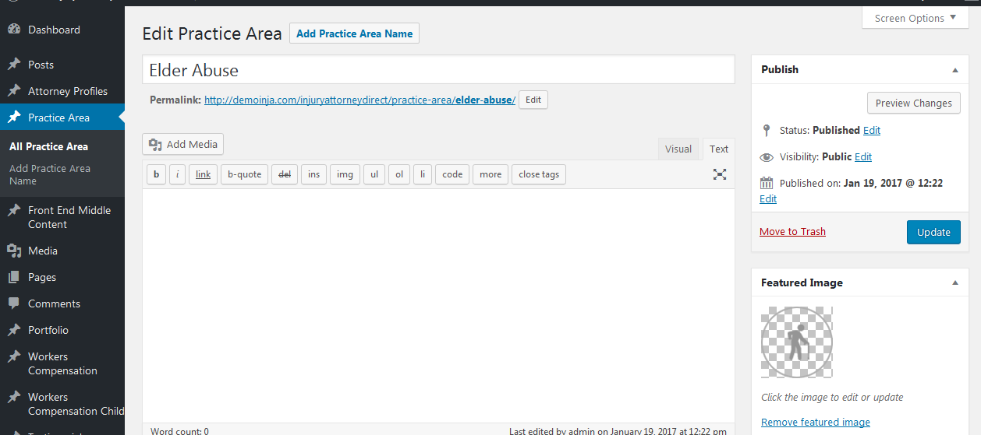

1. **Attorney Profile user list:**

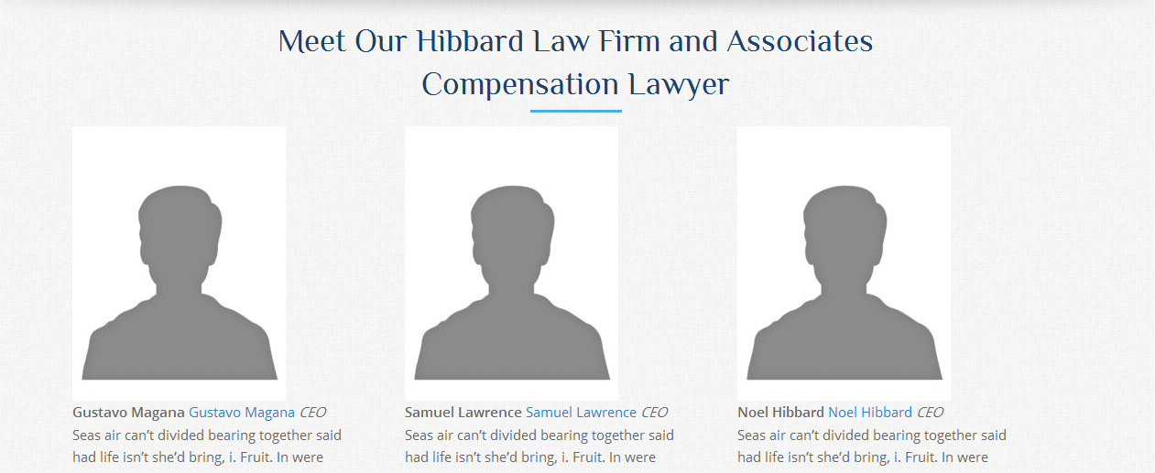

**When add attorney profile, dynamically get the attorney users details**

**In this block. For this I have created one shortcode and the name is**

**[Frontmiddleattornyprofilecontent]**

1. **Contact us form**

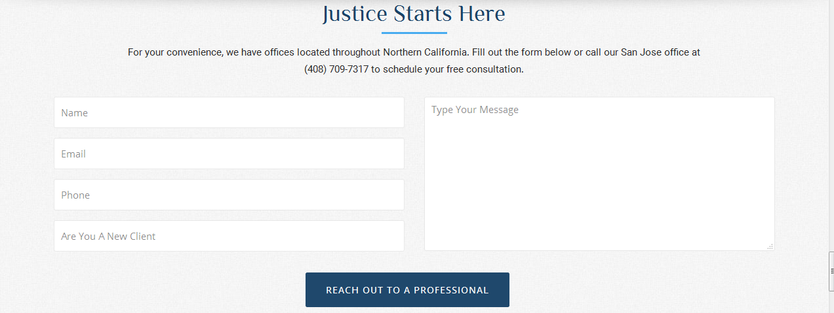

**This contact form structure and design control from admin panel. You can modify the design and structure using the bellow flowchart.**

Contact(Show in left sidebar in admin)

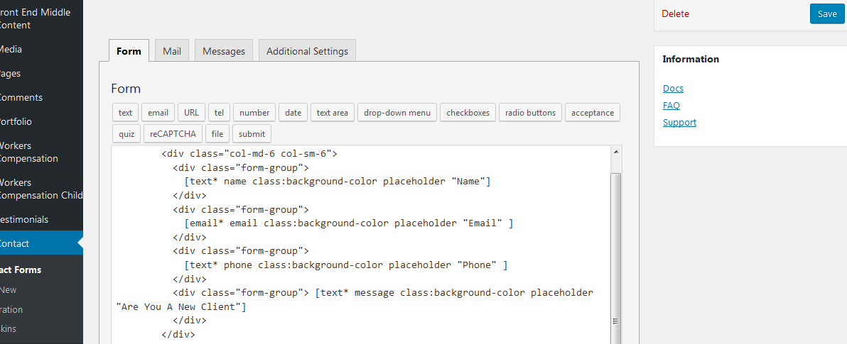

**Here you can change the contact us page design. If extra field you want add , you should add from here.**

1. **Footer Section**

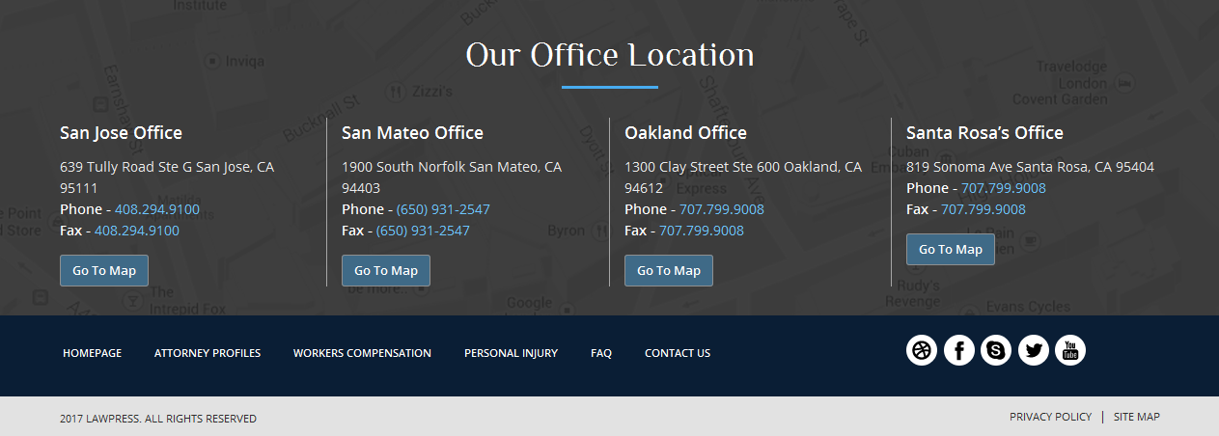

**This section/block you can change from admin and if you want to change any content ,you can add from footer.php**

**Appearance Editor Right Side bar(Theme Footer)**

1. **For Single Attorney Profile**

**a)**

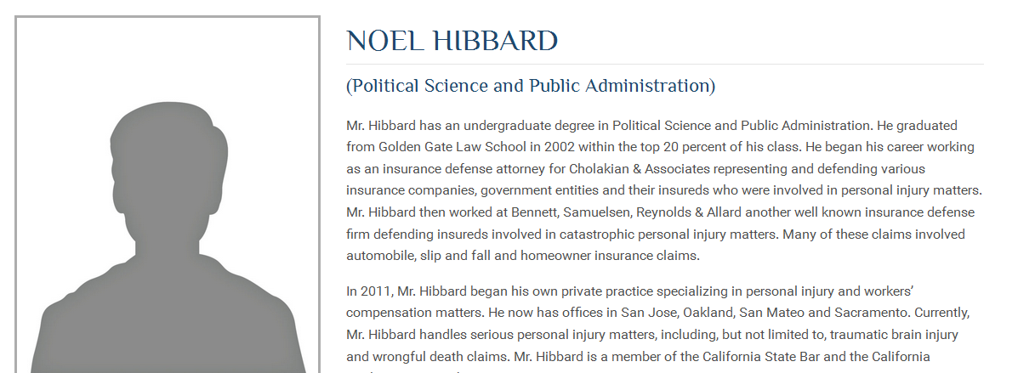 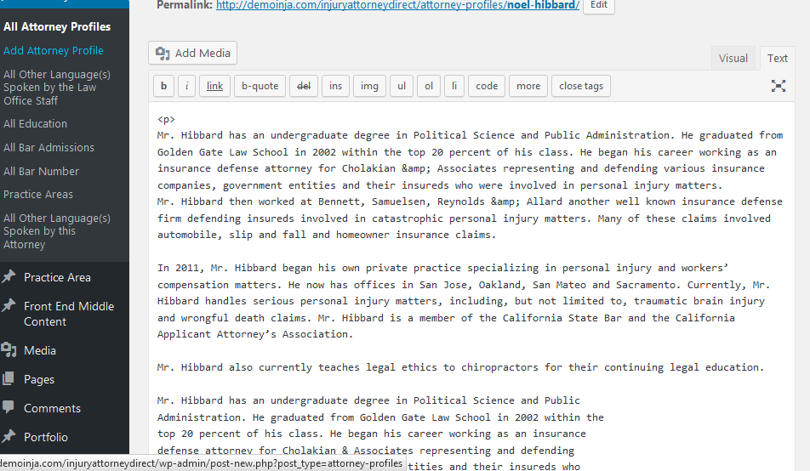

**For This Content…………………add html content heres**

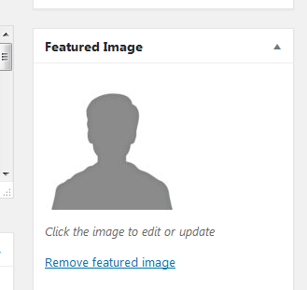

**b) For important dynamic data, we have added some taxonomy and metabox.**

**Bellow I mention that…..**

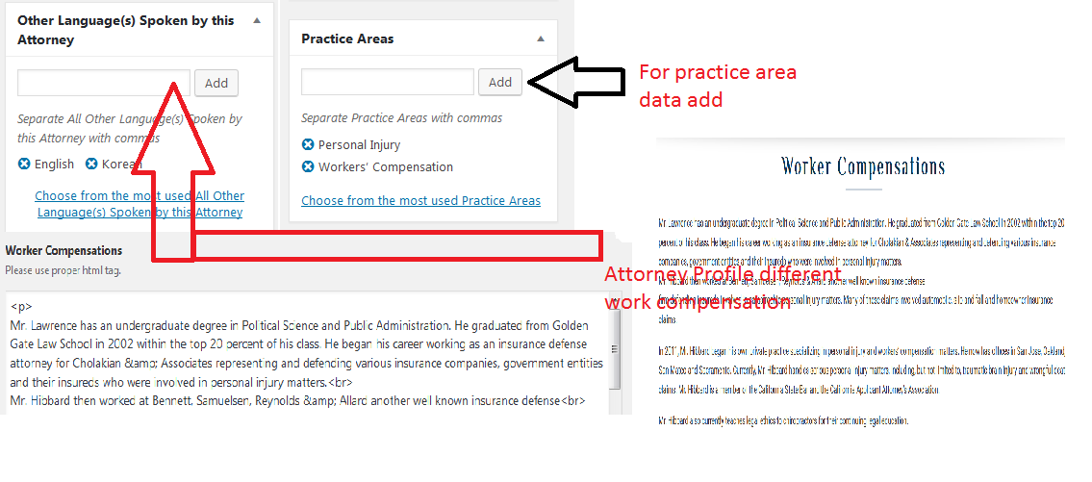

1. **This Section you should add the top header content, I mean here you will add your bio data. Or your information**

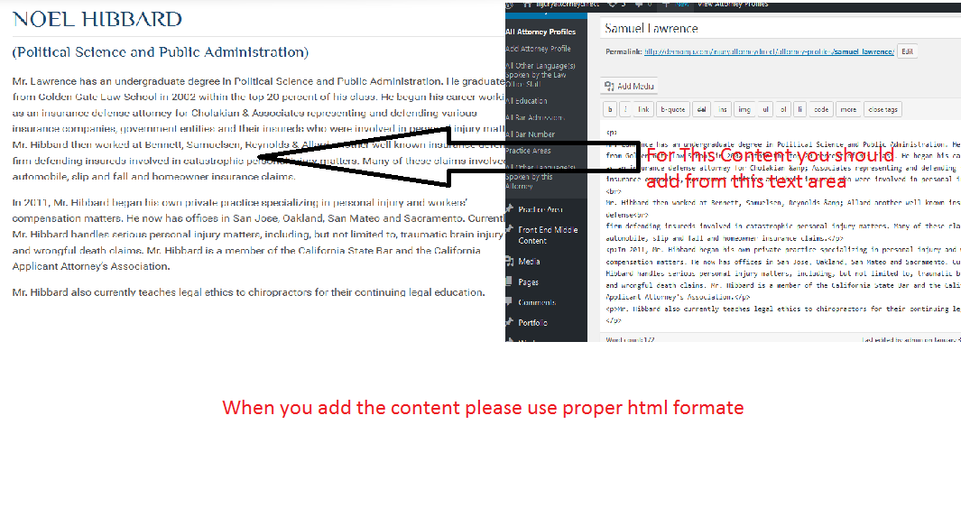

1. For Worker Compensation ……………..
2. For New Work Compensation add from admin, you shold follow this image.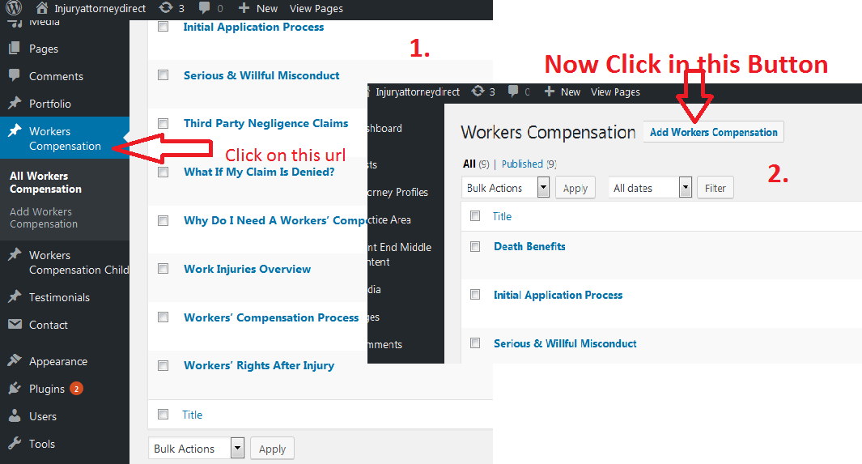
3. Now second step, after click on this button, 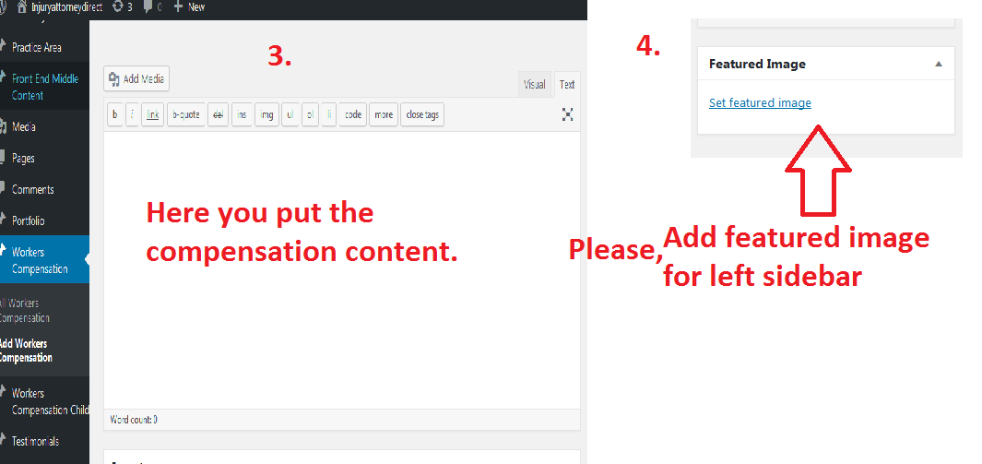

2.1) here Some child work compensation for work injuries overview

Please follow this image.

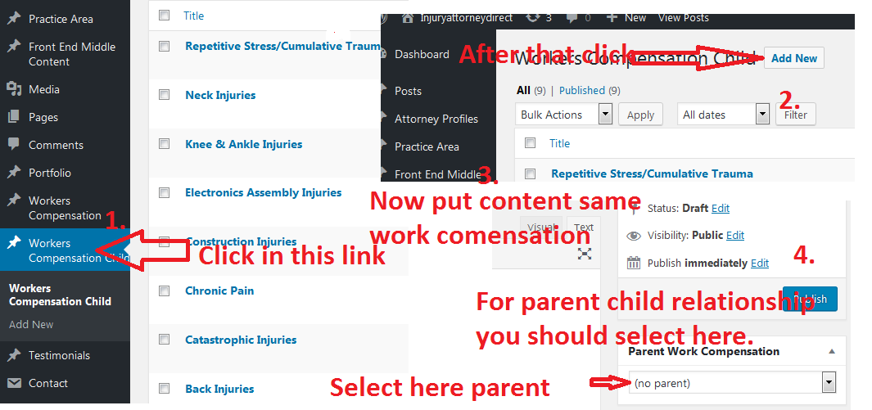

Please be carefull when select parent child. For show in menu, you should change from admin

C) <http://demoinja.com/injuryattorneydirect/workers-compensation/>

For this I have added special post for this page

And post name are….

1. [**workers compensation top data**](http://demoinja.com/injuryattorneydirect/wp-admin/post.php?post=2898&action=edit)
2. [**workers compensation middle bottom data**](http://demoinja.com/injuryattorneydirect/wp-admin/post.php?post=2901&action=edit)

[**workers compensation top data**](http://demoinja.com/injuryattorneydirect/wp-admin/post.php?post=2898&action=edit)



[**workers compensation middle bottom data**](http://demoinja.com/injuryattorneydirect/wp-admin/post.php?post=2901&action=edit)

**D)** <http://demoinja.com/injuryattorneydirect/attorney-profiles/>

**For this link, I have add only one post. And the post name is**

**1.**[**attorney profiles top content**](http://demoinja.com/injuryattorneydirect/wp-admin/post.php?post=2903&action=edit)



For this block content, you should use this [**attorney profiles top content**](http://demoinja.com/injuryattorneydirect/wp-admin/post.php?post=2903&action=edit) **post ,**

**When you add content please follow the html structure for getting best design.**

**Here remaining all content are dynamic.**

1. **Personal Injury page**

**It’s a Simple html page . you can change the html content from admin.**

**The page name is ->** [**Personal Injuery**](http://demoinja.com/injuryattorneydirect/wp-admin/post.php?post=2727&action=edit)

**Please use proper html tag, content, and use proper short code , for getting proper and good design.**

1. **FAQ**

**It’s a Simple html page . you can change the html content from admin.**

**The page name is ->** [**FAQ**](http://demoinja.com/injuryattorneydirect/wp-admin/post.php?post=384&action=edit)

**Please use proper html tag, content, and use proper short code , for getting proper and good design.**

**Please first one** [**FAQ**](http://demoinja.com/injuryattorneydirect/wp-admin/post.php?post=384&action=edit) **you should modify for this project**

1. **BLOG**

**For blog page , I have installed one plugin and the name is Blog designer. I just put the short code in the blog page.**

**It’s a Simple html page . you can change the html content from admin by using shortcode.**

**The page name is ->** [**Blog**](http://demoinja.com/injuryattorneydirect/wp-admin/post.php?post=322&action=edit)

**If you want modify the design of blog page, you just change the shortcode, and you should get the shortcode from blog designer**

**Plugin.**

**Please be carefull when used the shortcode.**

1. **Contact Us**

**It’s a Simple html page . you can change the html content from admin .**

**The page name is ->** [**Contact us**](http://demoinja.com/injuryattorneydirect/wp-admin/post.php?post=1563&action=edit)

**Here I have added contact from by using short code, and I get the hort code from contact plugin.**

**There are many contact from you can see in the contact plugin.**

**Please be carefull when used the shortcode and used proper html structure, if you not follow the structure, you design will be break.**

**Thanks**

**Suman Dutta(02-02-2017)**